CHEMICAL-MECHANICAL POLISHING (CMP)

Revision | Changes made | Date | Initials
A | Initial Document | 5/27/04 | PM

1.0 TITLE
Chemical-Mechanical Polishing

2.0 EQUIPMENT SET
Strasbaugh 6DS-SP Planarizer

3.0 FACILITIES
Power: 208V
Air Requirements: 100psi @ 10cfm
Vacuum Requirements: 20 in Hg (min.)

4.0 PURPOSE
The Strasbaugh 6DS-SP Planarizer is a chemical-mechanical polisher used for polishing oxides and metals on 4”, 6” and 8” wafers. Planarization of the wafer surface is achieved by chemical and mechanical mechanisms acting on the surface through chemical reactions and mechanical abrasion. The machine is equipped to process wafers automatically, and when needed, can be operated in a manual operation mode.

5.0 GENERAL MACHINE INFORMATION
The tool consists of 2 polishing tables, 2 spindles, a transfer bridge, 2 unload/load stations, a wafer carrier, a transport robot, 3 wafer cassette elevator stations and a pad conditioning arm.

5.1 Load/ Unload Station
The unload/load station are used to position the wafer directly underneath the wafer carrier/spindle assembly. Bottom-side vacuum sensors located underneath the wafer (see Figure 1) are used to sense for the presence of a wafer by making contact with the bottom-side of the wafer and drawing a small vacuum. In the automatic run mode, if the sensors do not sense a wafer present, the machine will time out. In some cases the surface roughness of the wafer will cause an inadequate vacuum seal and cause the machine to time out.

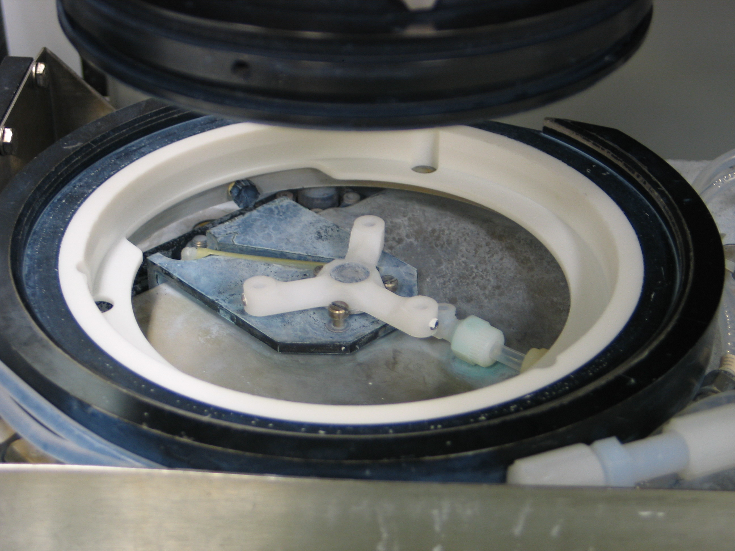

vacuum sensor

Figure 1. Load/unload station with bottom-side vacuum sensor in view.

5.2 Wafer Carrier
The wafer carrier is attached to the spindle by vacuum and is used to hold the wafer during polishing. Some carriers are retrofitted with safety clamps for attachment to the spindle during operation. Depending on the application, vacuum or backpressure can be used during the polishing cycle. There are carrier sizes available to accommodate 4”, 6” and 8” wafers. However, the DARPA project currently processes 4” wafers only. The wafer carrier contains a carrier film that is used to provide a soft medium between the vacuum chuck hard surface and the wafer. The carrier film should be replaced if there are any signs of deterioration or damage. Not cleaning the film after use and allowing slurry residue to dry on the film will degrade the film. During replacement, it is very critical that the vacuum holes in the carrier film are aligned with the carrier chuck vacuum holes to ensure proper vacuum.
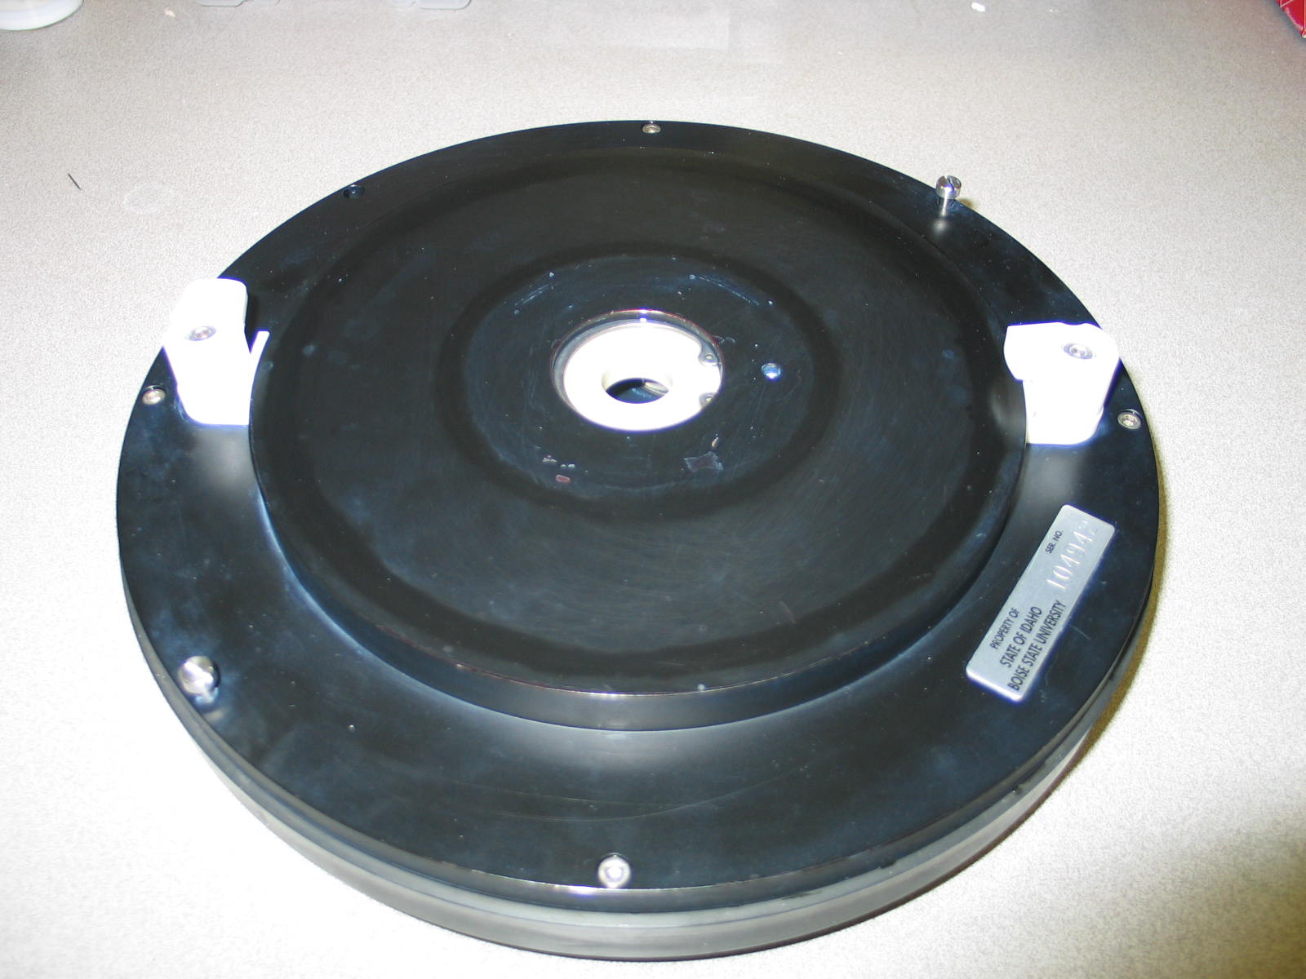
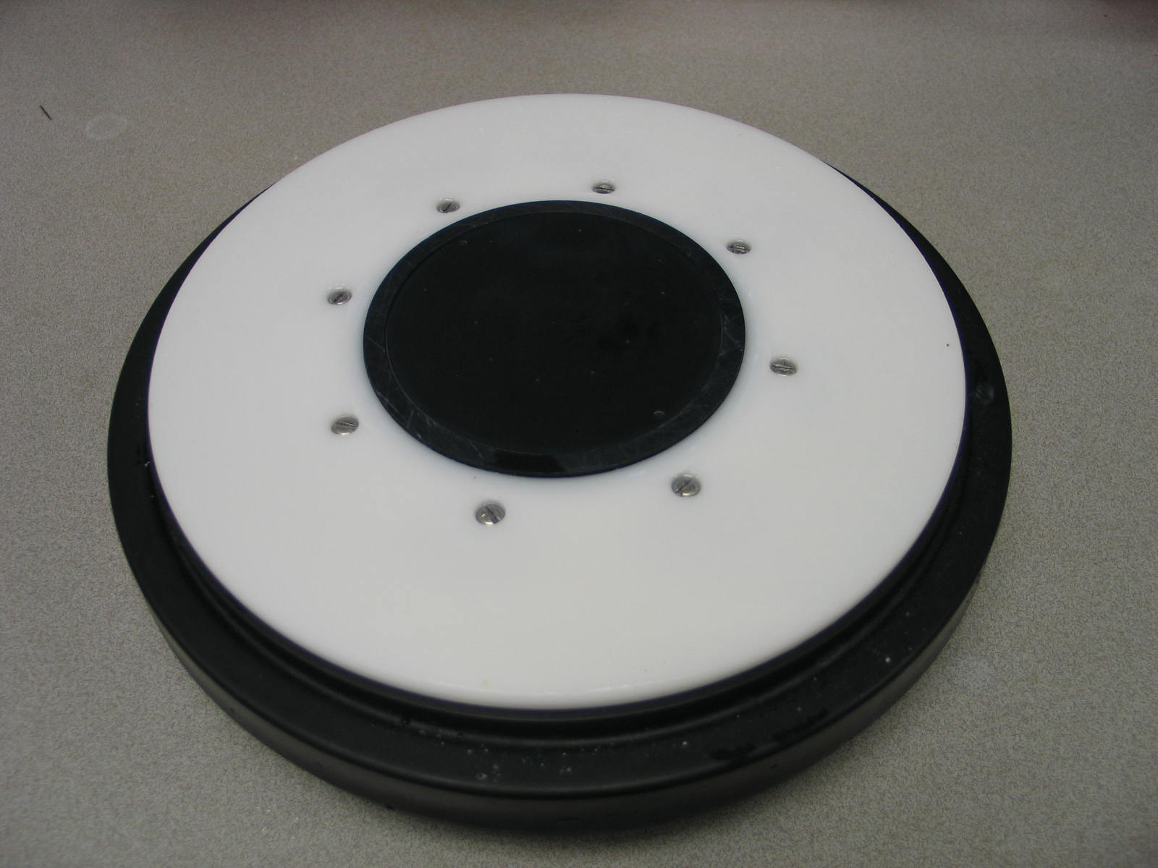
carrier film
safety clamps

Figure 2. Wafer Carrier bottom-side Figure 3. Wafer Carrier top-side
5.3 Wafer Cassette Elevators
The wafer cassette elevators are currently tooled to accommodate 8’ wafers. They are inoperable and are not required for current CMP requirements. Wafers that are smaller than 8” must be manually inserted onto the wafer carrier and processed from the loaded position. More details will be given on this process later in the procedure.

5.4 Polishing Pad
Polishing pads are used as the polishing medium to make contact with the wafer during polishing. They are used to transport the slurry to and away from the wafer surface. The polishing pads are generally made of a polyurethane material and can have a variety of surface textures and patterns on them. Some of the more common types of patterns are concentric circular pattern (Rodel’s K-groove), and a perforated pattern or XY-grid style. Pads come in a variety of hardness and diameters and are generally very expensive. For the DARPA CMP project, the pad size used is a 28in. diameter.
NOTE: Once a new pad has been placed on the machine it must be kept wet or pad deterioration will occur. The machine is equipped with a wet idle mode listed under the auto cycle menu options and can be used for short periods of machine idle. During wet idle, DI water will be dispensed onto the pad and will collect in the waste water collection system requiring tank level monitoring.

5.5 Slurry Dispense System
The Strasbaugh is equipped with 2 slurry pumps that are used to dispense slurry onto the polishing pad. Slurry pump 1 is the pump of primary use. After use, the pump and lines must be flushed with DI water to remove old slurry from the system.

5.6 CMP Copper Waste Collection and Disposal
CMP copper waste is collected in the waste collection system attached to the machine. Directly behind the machine is a sump tank used to catch large particles through settling. A sump pump located in the tank is then used to pump waste into the collection drums. There are three 55gal drums located on the right side of the machine that are used to collect waste. There is also a large 200gal tank located next to the drums which is used for waste collection and dumping treated waste to the facilities drain system.
Note: CMP waste can not be dumped to the facilities drain system unless the copper content is below 2 parts per million (ppm).
Testing of the waste for copper content is done by a qualified individual using the Atomic Absorption Spectrophotometer (AS). If the copper content is above 2ppm but below 6ppm, treatment or dilution can be done to lower the copper content. If the copper content is above 6ppm, the waste is usually pumped into other tanks to be disposed of offsite.
6.0 STRASBAUGH 6DS-SP OPERATING PROCEDURE

6.1 Preliminary
6.1.1 Ensure wafer carrier is not present on spindle

6.2 Machine Start-up
6.2.1 Turn on machine by pressing green start button.
-computer should turn on with start-up sequence shown on monitor.
-after power-up, system alarm will begin to beep. Press F10 to turn alarm off.
NOTE: Use [F9] to move between main menu options.
Use [F8] to move within sub-menus.
6.2.2 Turn on system vacuum. Wait for pump to draw vacuum down before turning on air supply.
6.2.3 Turn on system air supply.
6.2.4 Press [F9] to access homing machine menu [F5] located at the bottom of screen.
6.2.5 Press [F1] to home all axis.
6.2.6 Open door to cassette access and lift sensor arms of all cassette elevators. (elevators should raise)
6.2.7 Lower sensor arms back down. (elevators should lower back down).
6.2.8 Place wafer carrier on active load station.
6.2.9 Press [F6] to load wafer carrier onto spindle. (if wafer carrier is equipped with safety clamps, ensure safety clamps do not interfere with spindle vacuum lines while loading).
6.2.10 Spindle should come down and pick-up carrier and raise back up.

6.3 Slurry Dispensing
6.3.1 Mix slurry in accordance with mixing instructions
6.3.2 Place mixed slurry on automatic stirrer machine to continue mixing.
6.3.3 Place slurry suction tube into slurry beaker.
6.3.4 Press [F2] from main menu for slurry flush.
6.3.5 Press green start button on machine main control panel to start pump.
6.3.6 Slurry should begin to pump through lines and onto polishing pad.
6.3.7 To flush slurry out of lines, use a beaker filled with DI water and pump throughout system.

6.4 Automatic Mode - Loading Recipe
6.4.1 Press [F3] to access recipe screen.
6.4.2 Highlight recipe to be used and press [F3] to load recipe into machine.
6.4.3 To change recipe settings, press [F4] to access polish parameters menu.
6.4.4 Change recipe parameters according to the desired settings. (changes can not be made to recipes while logged in as an “operator”).
6.4.5 After recipe had been loaded into machine you are now ready to run a wafer.

6.5 Automatic Mode Operation
6.5.1 Press [F1-auto cycle] to access run screen.
6.5.2 Manually place wafer in carrier with the side to be polished facing down. (spray a small amount of DI water onto wafer and carrier film to help hold the wafer in place while loading). Make sure wafer is centered in carrier.
6.5.3 Press [F6- unload wafer] to unload wafer onto load/unload station.
6.5.4 Press [F3 - start with load] then press [cycle start] on machine panel to start cycle with wafer in loaded position.
NOTE: At this point the wafer vacuum sensors should move up and down looking for a wafer to be present on the load station. Once a wafer has been sensed, the spindle will come down and pick up the wafer and proceed with the recipe.
6.5.5 After completion of the recipe, the wafer carrier will transfer the wafer to the unload/load station. (If left to continue, the machine will try to transfer the wafer to the elevator. [F10] can be used to stop the cycle after the wafer carrier has unloaded the wafer).

6.6 Manual Mode Operation
6.6.1 Follow the same procedure for machine start-up.
6.6.2 Press [F9] from main menu to access manual control [F2] screen.
(press [F5] and [F6] to scroll through the different manual control screens.)
6.6.3 Manually load wafer onto wafer carrier with the side to be polished facing down. (spray the wafer with DI to help hold the wafer in place prior to turning on the vacuum). Use [F3] to view menu options under each parameter setting.
6.6.4 Activate the wafer carrier vacuum by pressing [enable] backpressure on the active spindle. Page 1 of the sub-menu
6.6.5 Select [Pol tble 1] to move the bridge above the polishing table. page 1.
6.6.6 Input the rotation speed into the polishing speed parameter. page 2.
6.6.7 Input the rotation speed into the spindle speed parameter. page 2.
6.6.8 Activate the slurry flow by setting the desired flow rate in the menu under the slurry flow rate parameter. page 3.
6.6.9 Input the desired down force. page 2.
6.6.10 Move the spindle down by selecting the [spindle down] position. page 2.
6.6.11 Start the timer for the amount of time the wafer is to be polished.
6.6.12 After the wafer has been polished, raise the spindle by selecting [spindle up].
6.6.13 Stop the slurry feed, table speed, spindle speed by setting each parameter to [0].
6.6.14 Move the bridge back to the load position by selecting [load] under the bridge move option. (after the bridge has been moved to the load station, the wafer carrier vacuum will automatically shut off). p1
6.6.15 Press [F8] to change the menu to auto mode and select [F6] to unload the wafer.
6.6.16 Quickly remove the wafer and rinse with DI water.

6.7 Changing the Polishing Pad
6.7.1 Remove slurry dispense lines from table.
6.7.2 Remove old pad by peeling pad from polishing table.
6.7.3 Clean table surface of any adhesive residue and slurry residue.
6.7.4 Allow table to be thoroughly dry before placing new pad on table.
6.7.5 Partially peel adhesive backing film from the new pad and align the pad with table.
6.6.6 Apply pad to table using care not to trap any air underneath pad.
6.7.7 Roll edge of pad with roller to seal edges of pad to table.
6.7.8 Re-attach slurry dispense lines.
6.7.9 Condition pad according to conditioning instructions.
6.7.10 The pad is now ready for use.
Note: As mentioned earlier, pads should be kept wet between uses to prevent deterioration of pad surface. If this is not possible, condition pad for 5 cycles, rinse thoroughly and this will minimize crystallized slurry particles left on the pad.

6.8 Pad Conditioning
6.8.1 Inspect conditioning disk located on the end of the conditioning arm prior to use.
6.8.2 Press [F1] to access auto cycle screen.
6.8.3 Press [F3 – demand cond.] under the automatic mode screen to run conditioning program.
6.8.4 For a new pad, the conditioning routine should be run a minimum of 3 cycles.

6.9 Changing the Carrier Film
6.9.1 Remove the (8) retainer ring screws.
6.9.2 Remove the white retaining ring.
6.9.3 Remove the black backing ring.
6.9.4 Remove the shim(s) located underneath backing ring.
6.9.5 Carefully remove the carrier film and any adhesive residue.
6.9.6 Clean surface with IPA (isopropyl alcohol) and dry.
6.9.7 Re-apply new carrier film by aligning the hole pattern between the film and carrier.
6.9.8 Make sure there are no air pockets in carrier film.
6.9.9 Replace the appropriate shims and place the backing ring back on.
6.9.10 Re-attach the retainer ring and screws.
6.9.11 The screws do have a torque requirement of 12in-lbs. Use a torque screw-driver to screw them back in.
6.9.12 The carrier is now ready for use.

TROUBLESHOOTING

Symptom | Probable Cause | Corrective Action
Insufficient Vacuum at carrier or spindle | 1. Vacuum pump is off.  2. Vacuum solenoid is not activated | 1. Turn on vacuum pump.  2. Turn off air and allow vacuum pump to pump down chamber.
Carrier will not pick up wafer | 1. Insufficient vacuum. | 1. Check vacuum.
Spindle will not pick up carrier | 1. Insufficient vacuum. | 1. Check vacuum.
Machine will not run in auto mode after initialization. | 1. Wafer presence not detected at load station. | 1. Use wafer with flat surface.
Axis will not home during homing routine | 1. unknown | 1. Home each individual axis separately.

